Biological sampling guide

snow crab (Area 12, 12E, 12F et 19)
March 2025
Introduction :
At-sea observers collect data to determine the catch composition of snow crab in the fishery (e.g. crab size, sexual maturity), the amount of discards, and the proportion of soft/white crabs in the catch.
In order for these data to be reliable, it is important that:
- Samples are to be taken randomly. This also applies to the selection of fishing vessels, traps, and crabs. Random selection ensures that the samples taken are representative of the fishery catch.

- Measurements and data collected must be taken conscientiously. Time must be taken to measure the crab correctly, to read the instruments carefully, and to write down observations on the sampling sheets.
Matériaux :
Vernier caliper (x1) |  | Durometer (x2) |  | Data sheets
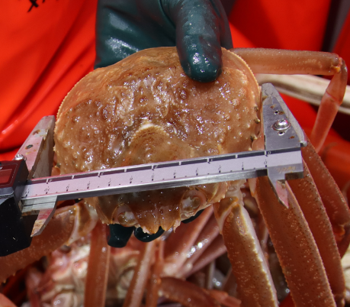 |  | 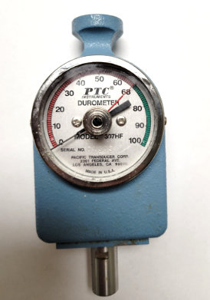 |  | 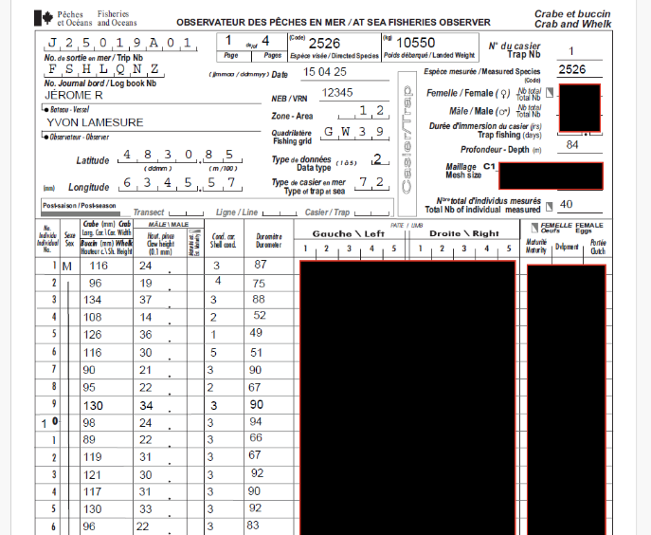
The Vernier caliper is used to measure the width of the carapace, as well as the height of the crab's claw. |  | The durometer is used to measure the hardness of the shell and helps determine if a crab is considered a softshell crab (i.e. a newly molted crab). |  | Example of a sampling data sheet for recording crab information and measurements.

Instrument verification and care :
Vernier caliper :
- The caliper must be intact and unmodified.
- Ensure that the instrument’s mechanisms are kept tight.
- If necessary, lubricate the instrument with a non-toxic oil (e.g. before use).
- Rinse with warm fresh water after use.
- Clean the measuring ruler to maintain good visibility.
Durometer :
- The instrument must be inspected and calibrated at the beginning of the season.
- Check if the black needle is at zero when resetting the instrument.
- On a hard metal surface, test if the needle goes to 100.
- It is also necessary to avoid shocks on the instrument so as not to lose its calibration. Keep the durometer in a safe place (e.g. attached to the neck).
Methods :
The observer must sample several traps during each trip. In order for the samples to be representative of the catch, it is important that the traps, as well as the crabs, be chosen at random.
There are two types of sampling. The first is called sampling of unsorted catches, i.e. before sorting by the crew. The second is called sampling of landed catches, i.e. after sorting by the crew. Table 1 presents a summary of the two types of sampling. Normally, two unsorted samples are taken for each sorted sample (a 2 to 1 ratio).

Table 1 : Summary of the two types of sampling for snow crab.

 | Sampling type
Details | Catches  (unsorted) | Landed catches  (sorted)
Code on data sheet | code = 2 | code = 1
Crab type | Males only | Males only
Sample timing | Before the crew sorts the catch | After the crew sorts the catch
Number of crabs per sample (random) | 40 crabs | 20 crabs

Information to record on sampling data sheets:
Figure 1 shows an example of a snow crab sampling sheet. Table 2 contains a summary of the information to record on each sheet. Table 3 contains a description of the instrument measurements to be performed on snow crab.

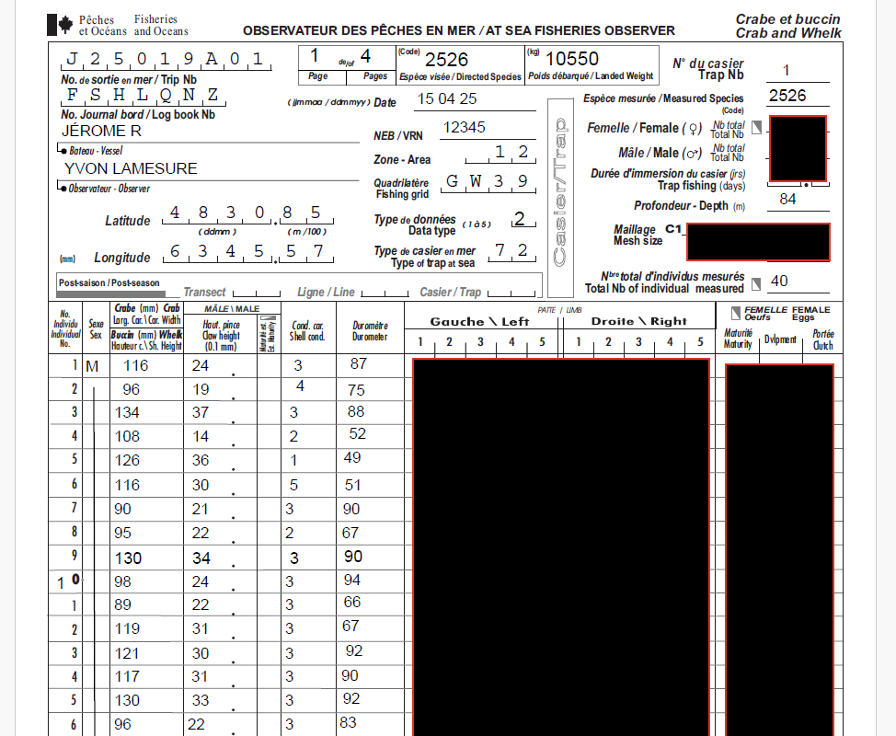
Figure 1 : Example of a sampling data sheet for snow crab. Blacked-out areas are no longer required.

Tableau 2 : Summary of information to be completed on the sampling sheets. Note that the blacked-out sections on the sampling sheet (Figure 1) are no longer required. All other fields must be completed.

Field | Description
Trip number | The trip number assigned by the observer company (ex : J25019A01).
Logbook number | The electronic logbook number (from the captain) (ex. FSHLQNZ).
Date | Sampling date. The format is day / month / year (dd/mm/yyyy).
Page | Data sheets must be numbered as follows : page number for the sample and the total number of pages for the trip (ex. 1 of 2, or 1/2).
CFV | Canadian fishing vessel number.
Vessel | Fishing vessel name.
Observer | Observer full name.
Area | Zone de pêche de crabe des neiges :  Area 12 code = 12  Cape Breton 19 code = 19  Area E code = 12E  Area F code = 12F
Position | Latitude / longitude coordinates of the sampled trap du casier. Coordinates must use the degree-decimal minute format  (ex . 48°30.85’; 63°45.57’).
Data type | Catches unsorted (code = 2), landed catches (code = 1).
Trap type | See codes supplied by the company to identify the trap type (ex : 72).
Directed species | Species code for snow crab is 2526.
Landed weight | Observer-estimated total landed weigth for the entire trip in kilograms (kg).
Trap number | For unsorted catches (data type 2), write the trap number on all sheets.  For landed catches (data type), write 99, 98, 97, etc. for each sample.
Measured species | The code for snow crab is 2526.
Total number of crab measured | The total number of crab measured on the data sheet..
Depth | Depth of crab trap in meters (m).
Sex | Crabs sex. Only males are measured (M).
Carapace width | Carapace width measurement in millimeters carapace (mm).
Claw height | Claw height measurement in millimeters (mm).
Shell condition | Shell condition (1 to 5). See Tables 4 & 5 and Figure 5.
Durometer | Durometer measurement from 0 to 100.
Comments | Note anomalies or other comments.

Table 3 : Summary of the instrument measures of snow crab.

Mesure | Image | Description | Units
Carapace width |  | Measurement of the width of the crab's carapace. The accuracy is to the nearest millimeter. | Millimetres
Claw height |  | Measurement of the height of the crab's right claw. The accuracy is to the nearest millimeter. | Millimetres
Durometer | 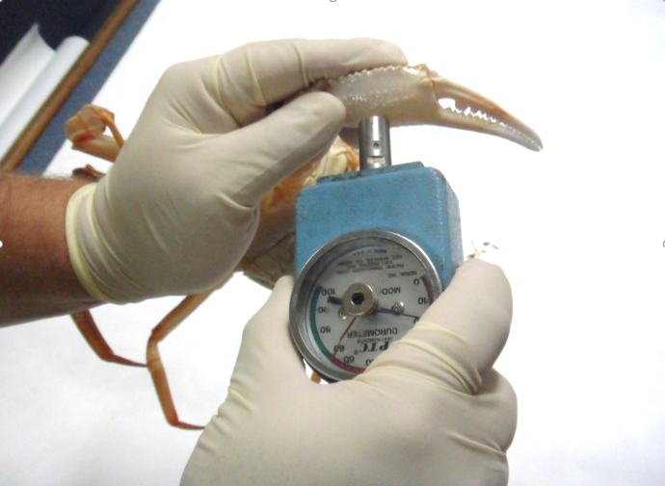 | Measurement of the hardness of the crab's right claw with the durometer. If the crab is very soft and the observer is concerned about damaging the claw, it is permissible to enter a value of 0. | Values from 0 à 100

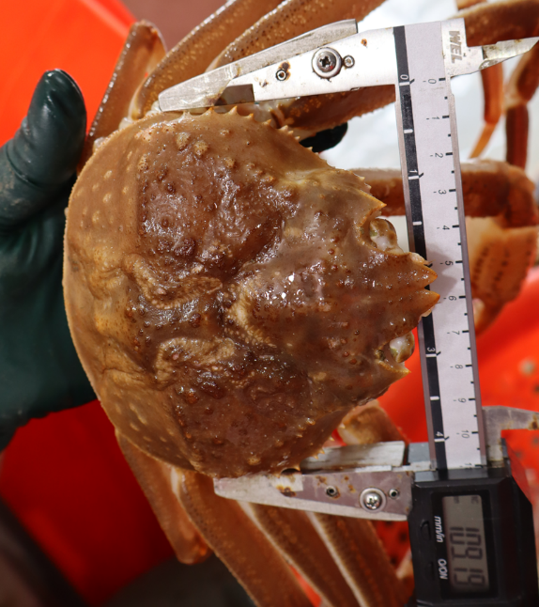
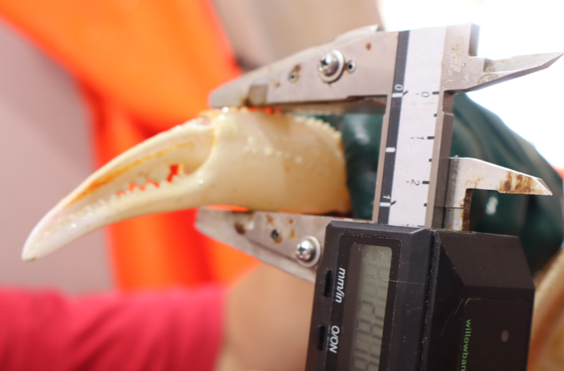 | 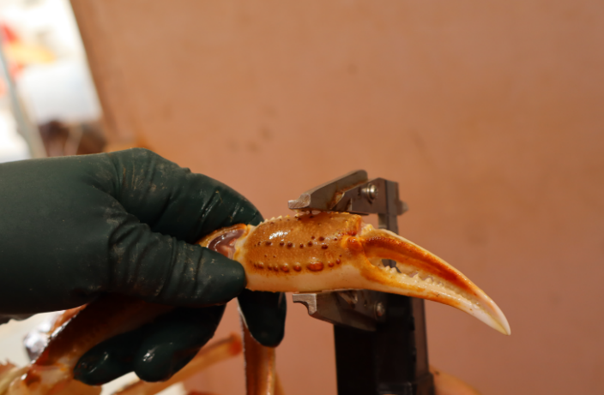
Figure 2 : Illustration of good snow crab measuring techniques. The top image shows the carapace width measurement. Note that the arms of the caliper are under the spines on either side of the carapace. The bottom two images show the claw height measurement. Note the orientation of the caliper, as well as its position on the claw.

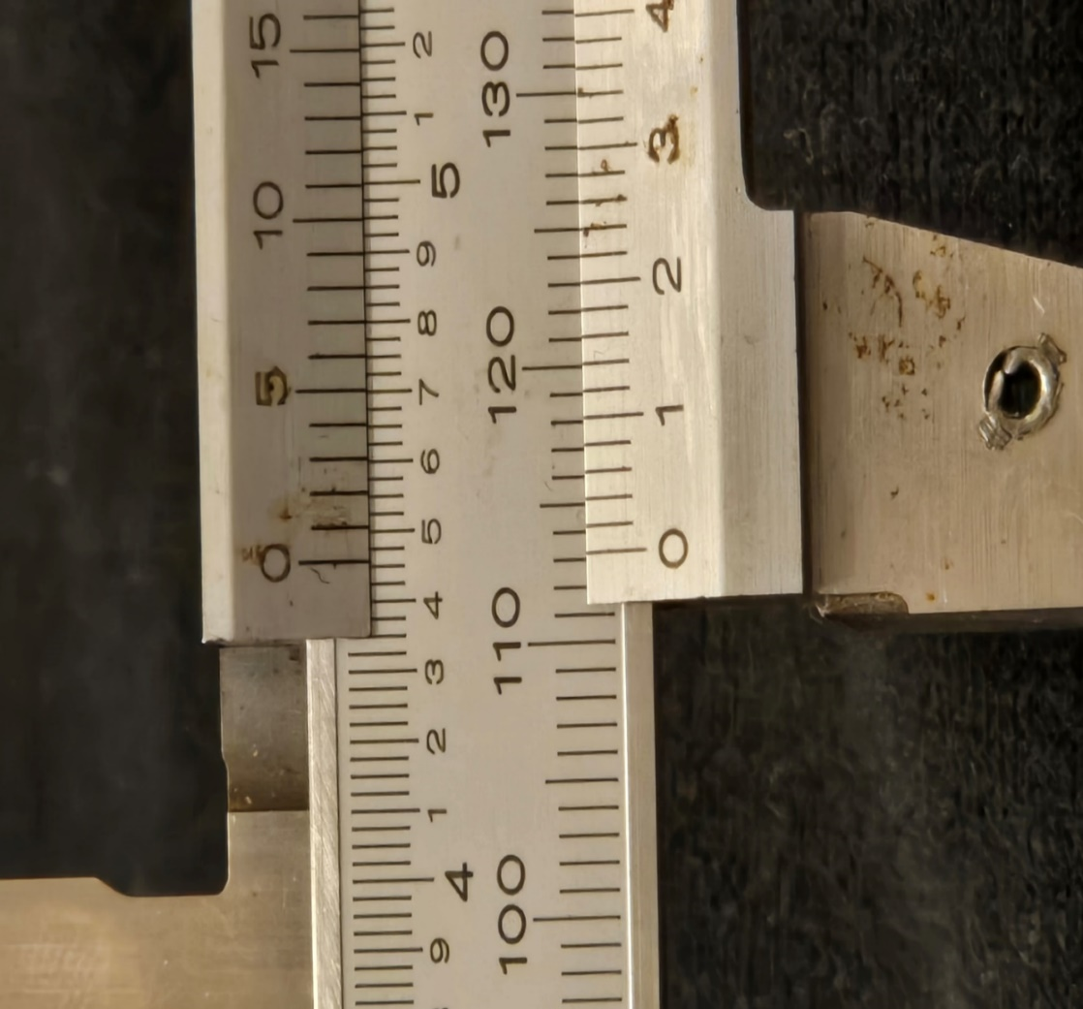
113 mm

Figure 3 : How to read the Vernier caliper. The ‘0’ line on the bottom scale lies between the values ​​of 113 mm and 114 mm on top. However, it is closer to the 113 mm line, so this is the one we record as the measurement.

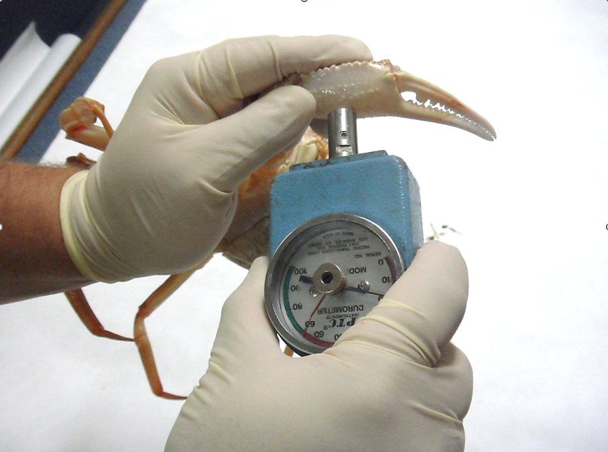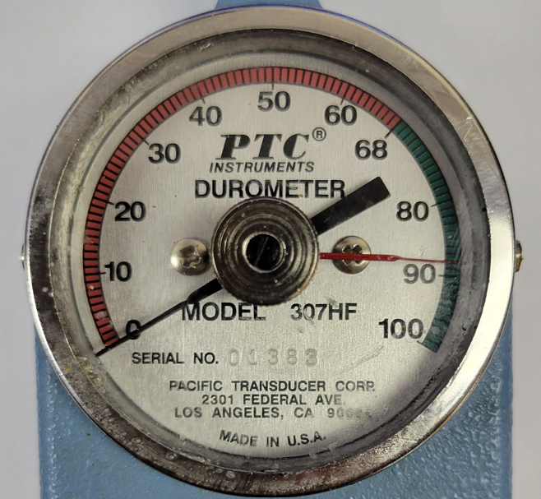
Figure 4 : Left: Example of proper application of the durometer to the ventral surface (the white side, at the bottom of the claw) of the snow crab's claw. Right: View of the durometer dial showing a measurement of 88 hardness units.

Tableau 4 : Sommaire des caractéristiques de la condition de carapace du crabe des neiges.
Variable | New-shelled crab |  | Old-shelled crab
Condition | 1 | 2 | 3 | 4 | 5
Description | New soft | New hard | Intermediate | Old | Very old
Time since moult | Less than 3 months. | 3 to 12 months. | More than a year. | 1-3 years. | 3+ years.
Carapace hardness | Firm, but relatively soft and flexible. | Carapace is harder and rigid. | The carapace is hard and firm. | The carapace is hard and firm. | Soft and spongy due to decalcification.
Claw hardness | Soft and breakable with thumb. | Hard and difficult to break with thumb. | Very hard to break. | Very hard to break. | Soft and spongy due to decalcification.
Carapace (dorsal) | Light reddish - brown. | Light reddish -brown. | Darker reddish -brown. | Dark brown. | Dark brown.
 | 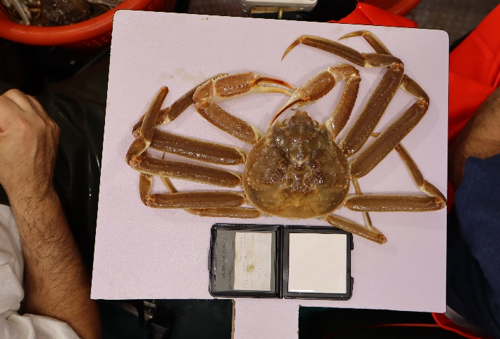 | 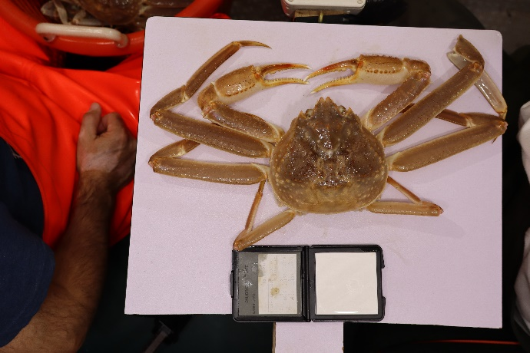 | 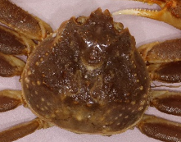 | 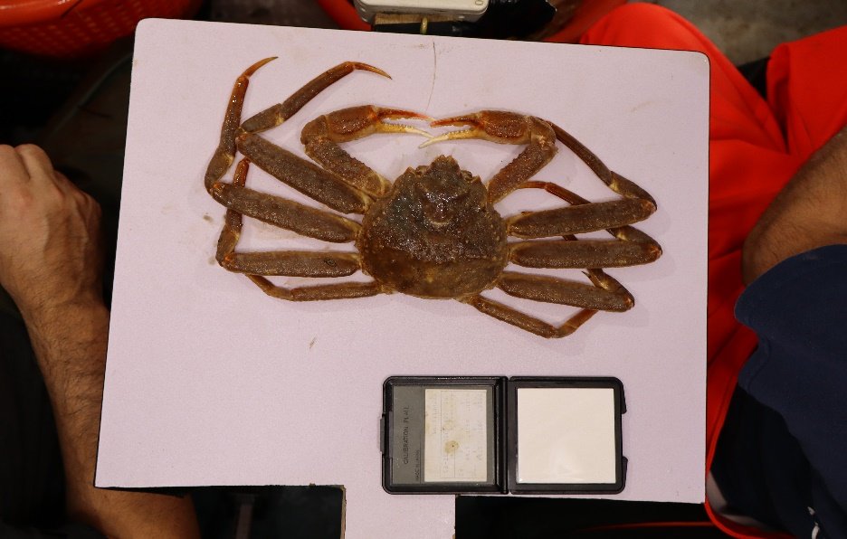 | 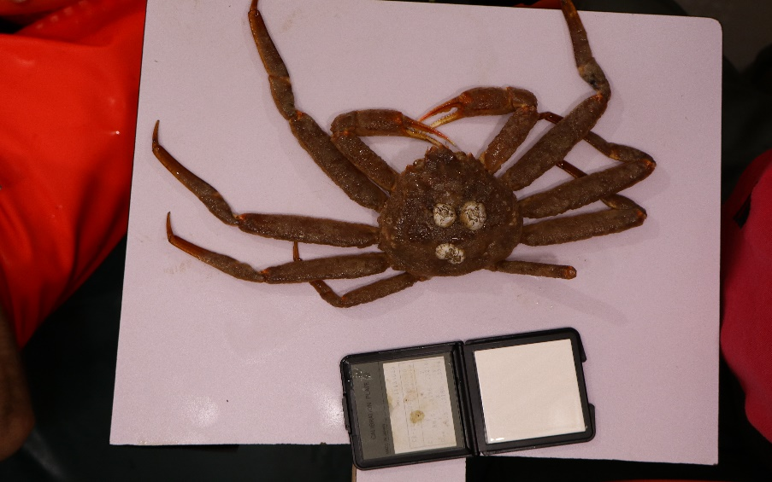
Carapace (ventral) | White, translucent & iridescent. | White & opaque, with some iridescence. | Yellow-beige. Iridescence in a very few places. | Yellowish brown, no iridescence. | Dark brown, no iridescence.
Epibionts  (surface organisms) | Carapace is very clean with no surface organisms. | Carapace is clean, but may have a few surface organisms. | May have some moss on the carapace. Barnacles and spirorbids may be visible. | Crab is mossy, with barnacles & spirorbids often present. | Heavy moss. May have extensive coverage by barnacles and spirorbids.
Spines & dactyls (leg tips) | Very pointy and sharp. | Very pointy and sharp. | Still sharp but showing signs of wear. | Worn and rounded. | Rounded and often damaged.
 | 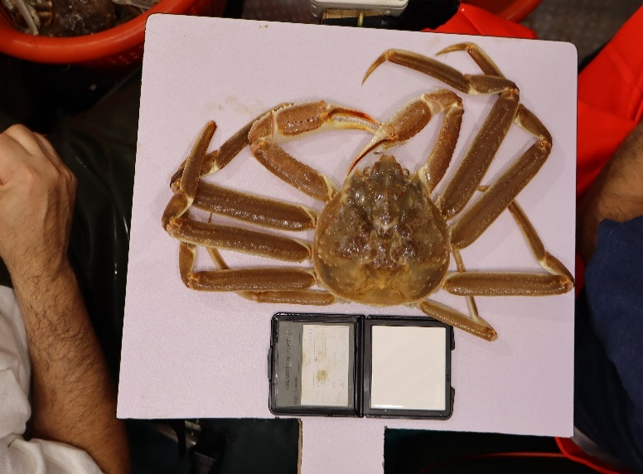 | 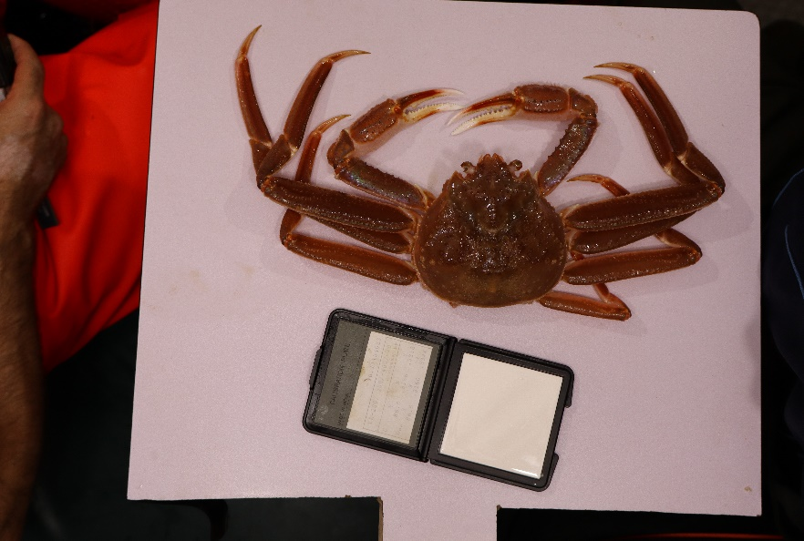 | 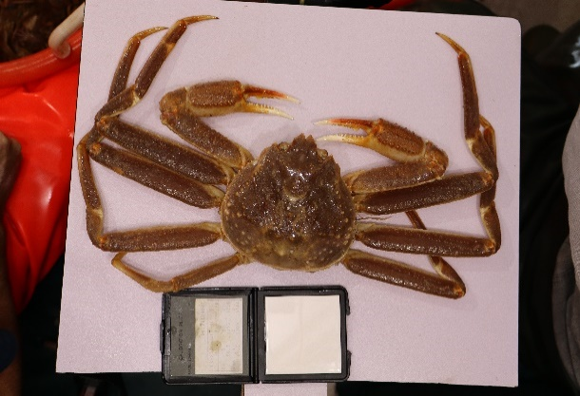 | 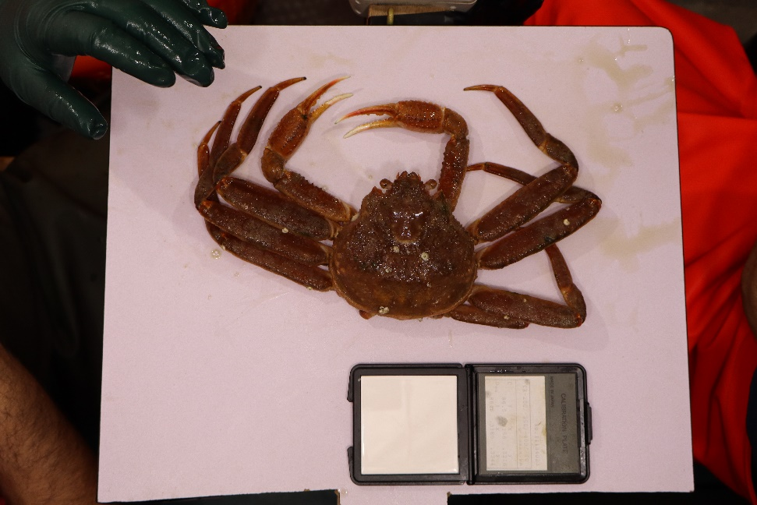 | 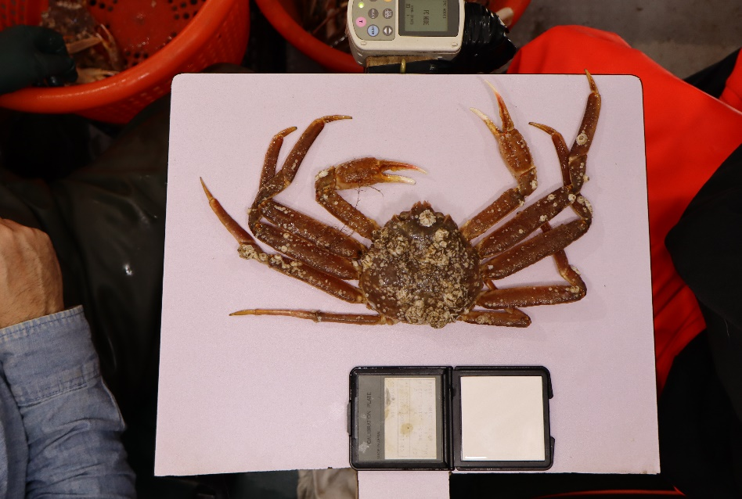
Scars & wear | No scars or wear. | Minimal scratches or wear. | Scars visible on the ventral surface. | Obvious scars, scratches and wear. | Scars & widespread wear on the carapace.
Missing legs | Rare | Rare | Occasional | Common | Frequent
Meat yield | Very low. | Low to medium. | Maximum level. | Maximum level. | Maximum level.

Table 5 : Representative examples of the 5 snow crab shell conditions.
Condition | Dorsal view | Ventral view
1 | 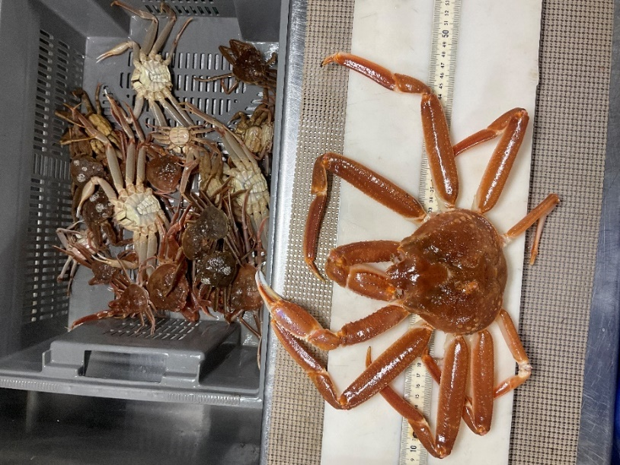 | 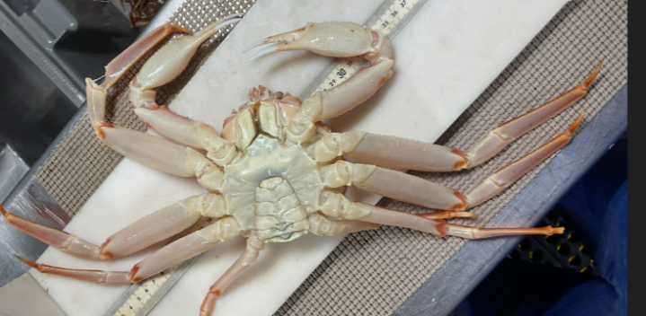
2 | 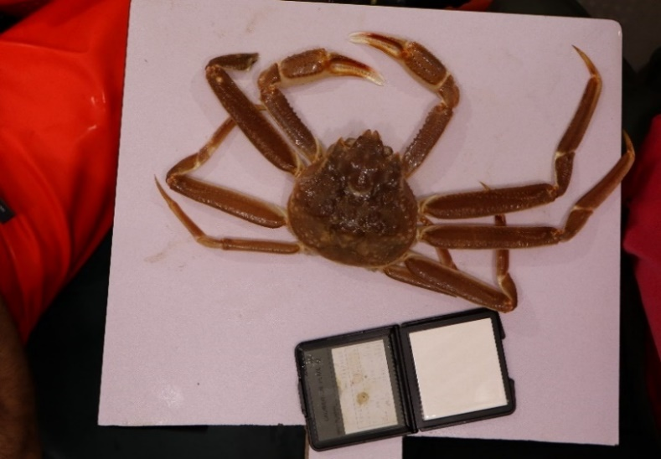 | 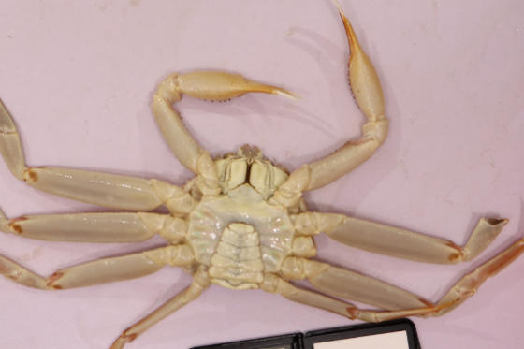
3 | 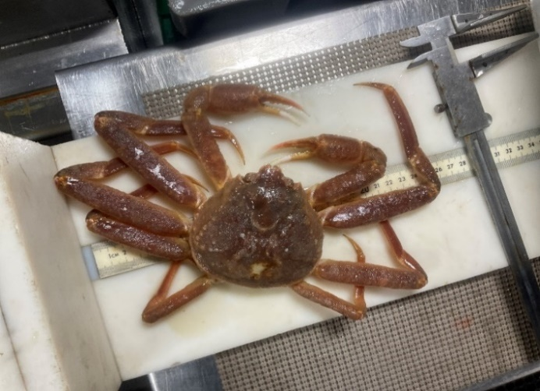 | 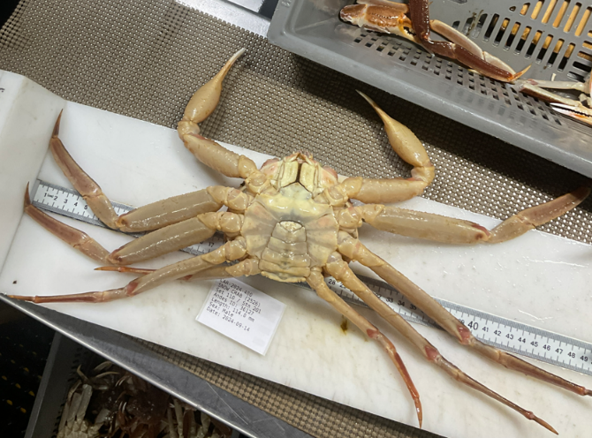
4 | 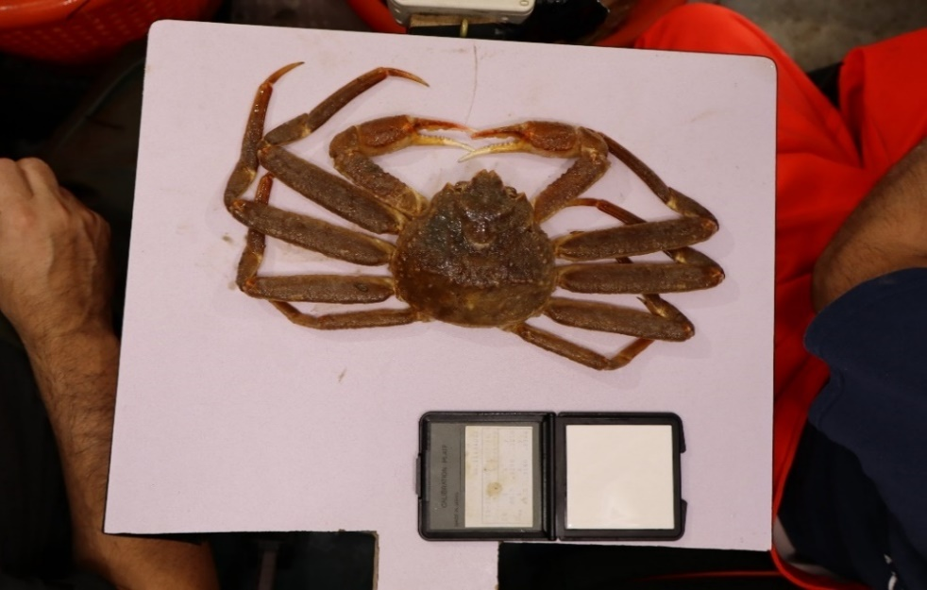 | 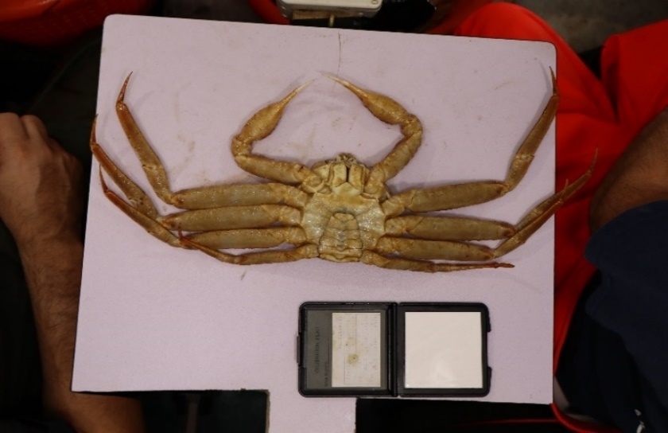
5 | 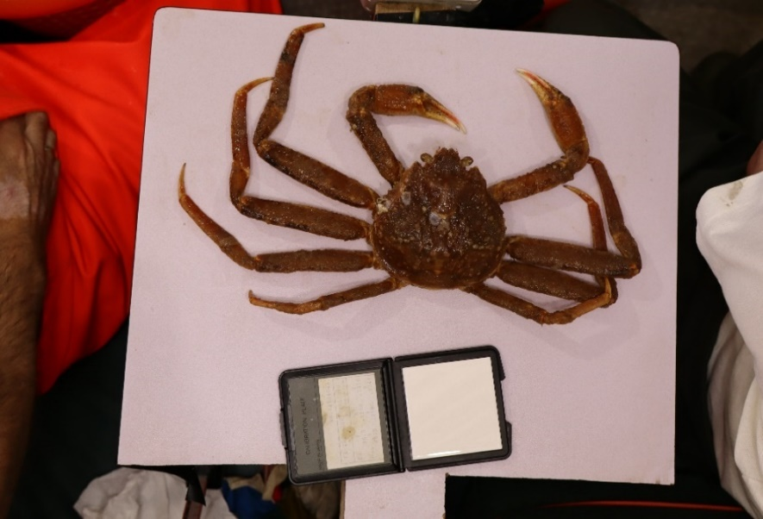 | 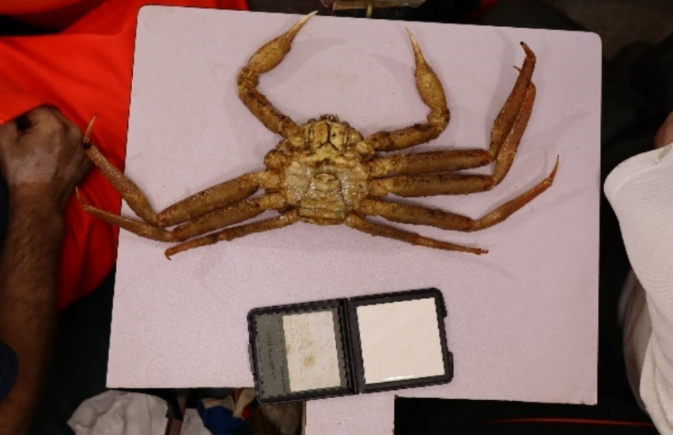

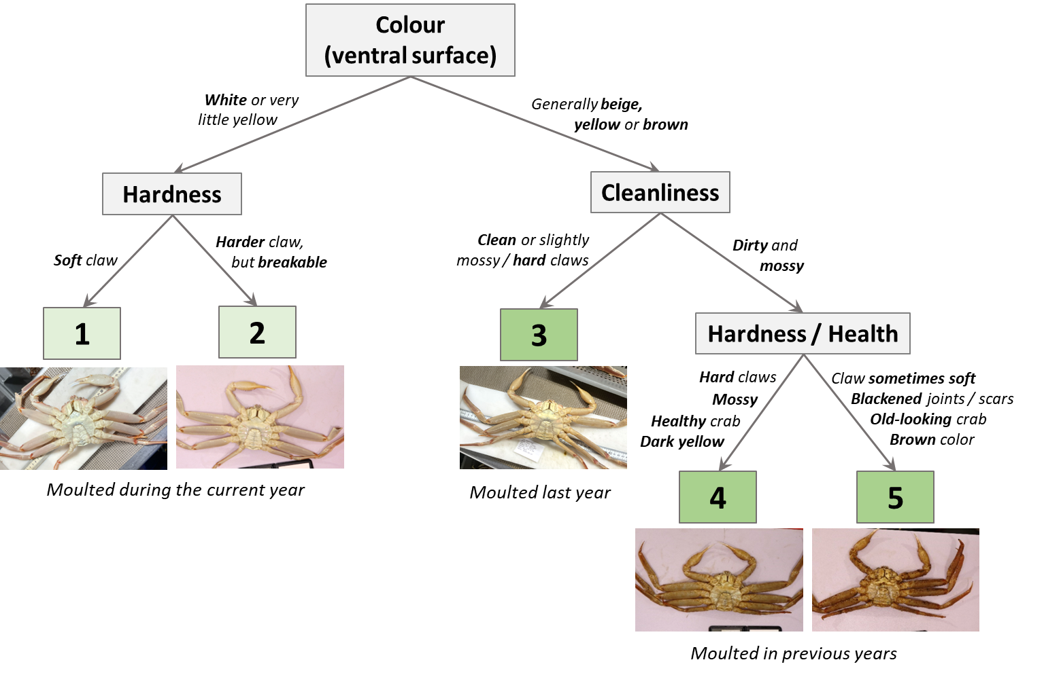
Figure 5 : Key for identifying snow crab shell conditions.

